**Introduction to Identity**

It is an API that manages users, passwords, profile data, roles, tokens, email confirmation, external logins etc.

It is by default built on top of EntityFrameworkCore; you can also create custom data stores.

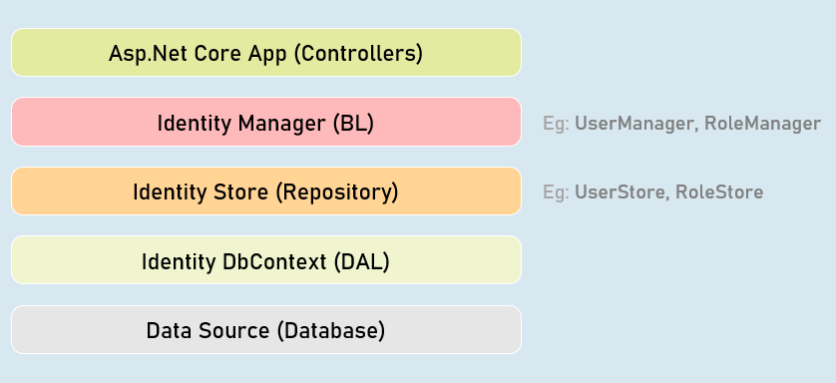

**IdentityUser<T>**

Acts as a base class for ApplicationUser class that acts as model class to store user details.

You can add additional properties to the ApplicationUser class.

**Built-in Properties:**

1. Id
2. UserName
3. PasswordHash
4. Email
5. PhoneNumber

**IdentityRole<T>**

Acts as a base class for ApplicationRole class that acts as model class to store role details. Eg: "admin"

You can add additional properties to the ApplicationRole class.

**Built-in Properties:**

1. Id
2. Name

**Register View**

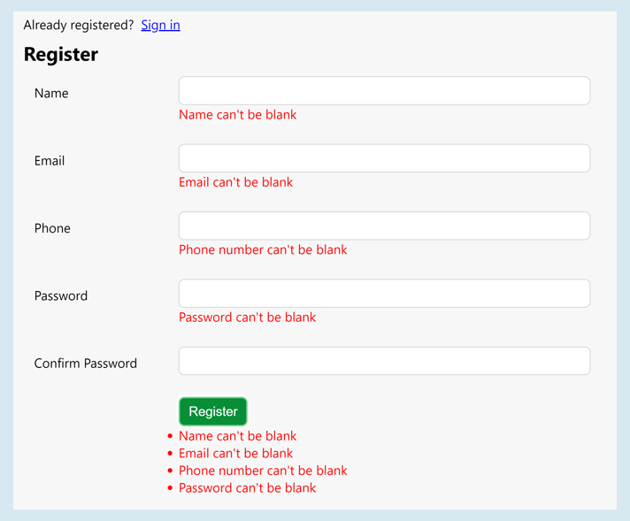

**Managers**

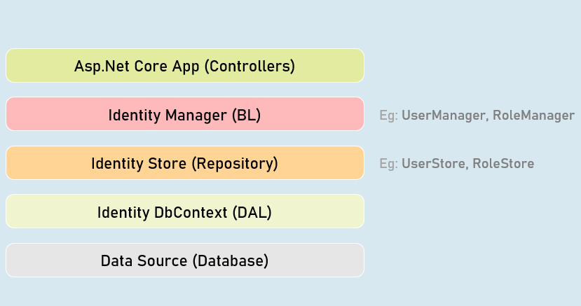

**UserManager**

Provides business logic methods for managing users.

It provides methods for creating, searching, updating and deleting users.

**Methods:**

* CreateAsync()
* DeleteAsync()
* UpdateAsync()
* IsInRoleAsync()FindByEmailAsync()
* FindByIdAsync()
* FindByNameAsync()

**SignInManager**

Provides business logic methods for sign-in and sign-in functionality of the users.

It provides methods for creating, searching, updating and deleting users.

**Methods:**

SignInAsync()

PasswordSignInAsync()

SignOutAsync()

IsSignedIn()

**Password Complexity Configuration**

services.AddIdentity<ApplicationUser, ApplicationRole>(options => {

options.Password.RequiredLength = 6; //number of characters required in password

options.Password.RequireNonAlphanumeric = true; //is non-alphanumeric characters (symbols)

required in password

options.Password.RequireUppercase = true; //is at least one upper case character required in password

options.Password.RequireLowercase = true; //is at least one lower case character required in password

options.Password.RequireDigit = true; //is at least one digit required in password

options.Password.RequiredUniqueChars = 1; //number of distinct characters required in password

})

.AddEntityFrameworkStores<ApplicationDbContext>()

.AddDefaultTokenProviders()

.AddUserStore<UserStore<ApplicationUser, ApplicationRole, ApplicationDbContext, Guid>>()

.AddRoleStore<RoleStore<ApplicationRole, ApplicationDbContext, Guid>>();

**Login/Logout Buttons**

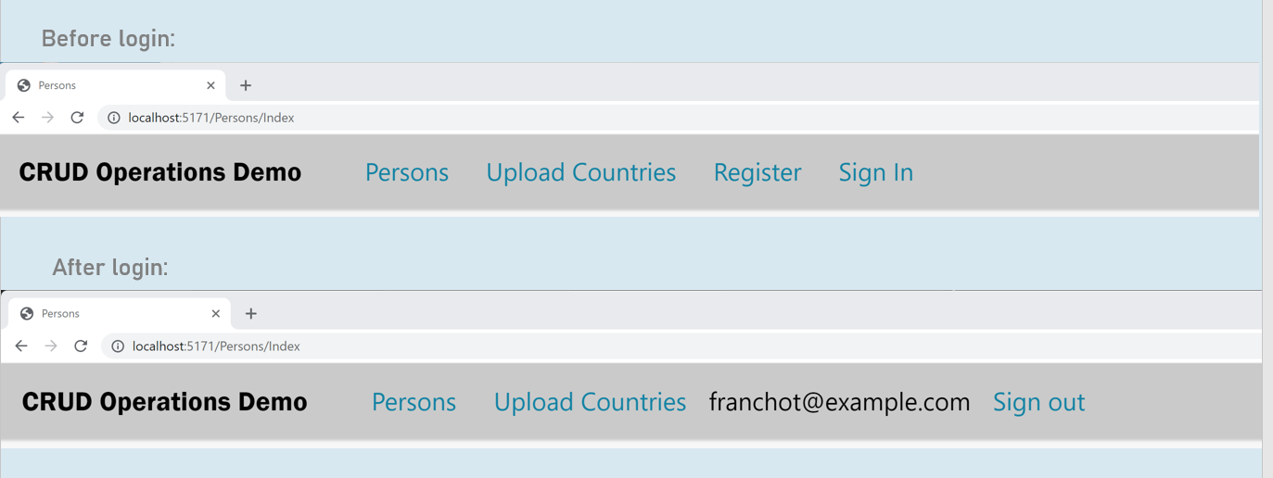

**Login View**

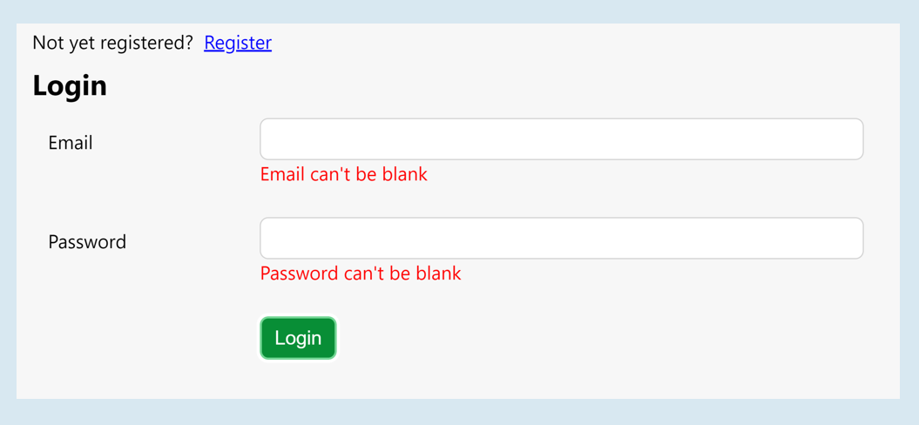

**Authorization Policy**

services.AddAuthorization(options =>

{

var policy = new AuthorizationPolicyBuilder().RequireAuthenticatedUser().Build();

options.FallbackPolicy = policy;

});

**ReturnUrl**

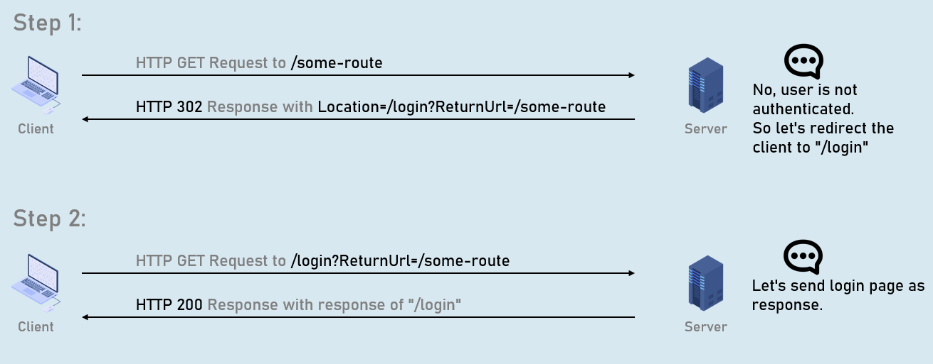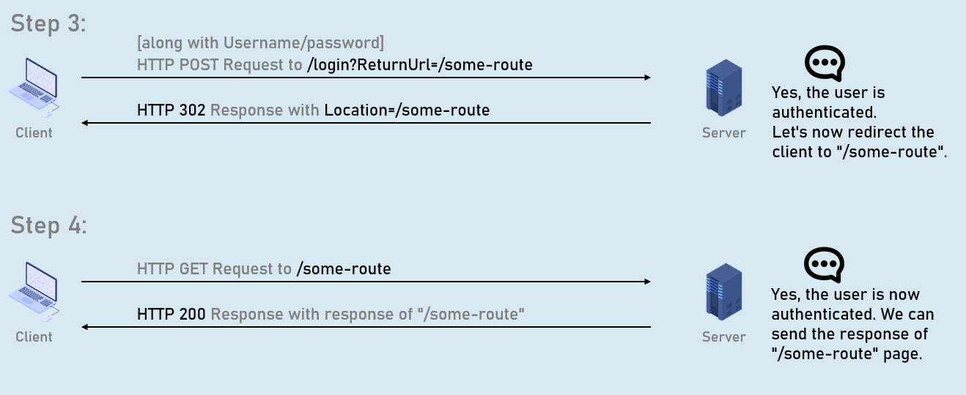

**Remote Validation**

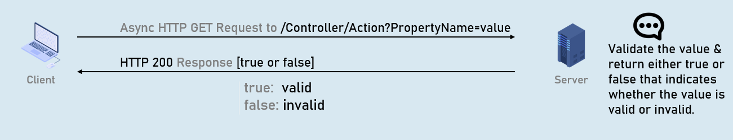

**Model class**

public class ModelClassName

{

[Remote(action: "action name", controller: "controller name", ErrorMessage = "error message")]

public type PropertyName { get; set; }

}

**Conventional Routing**

Conventional routing is a type of routing system in asp.net core that defines route templates applied on all controllers in the entire application.

You can override this using attribute routing on a specific action method.

endpoints.MapControllerRoute(

name: "default",

pattern: "{controller=Persons}/{action=Index}/{id?}"

);

**Areas**

Area is a group of related controllers, views and models that are related to specific module or specific user.

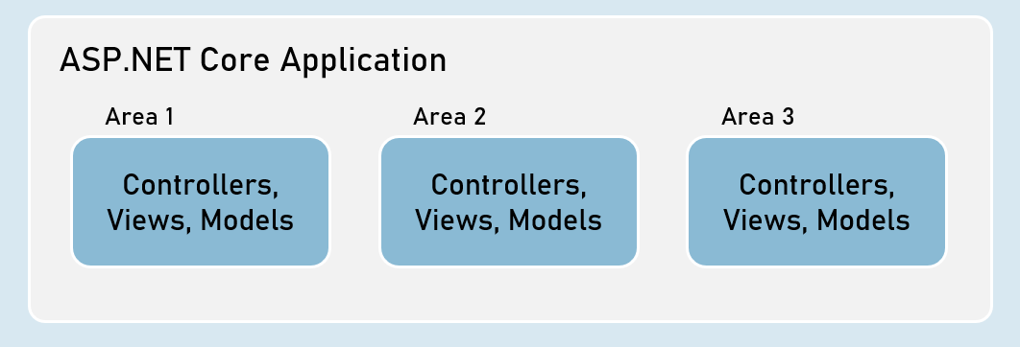

**User Roles**

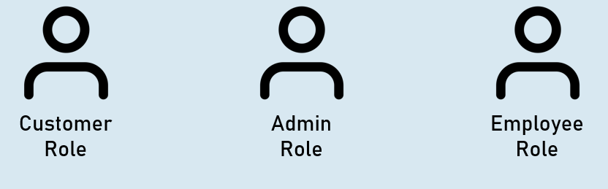

**Role Based Authentication**

User-role defines type of the user that has access to specific resources of the application.

Examples: Administrator role, Customer role etc.

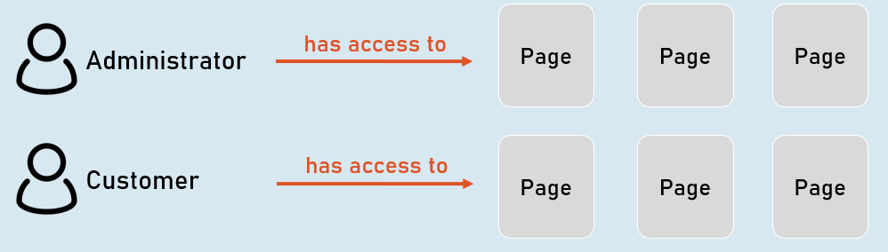

**HTTPS**

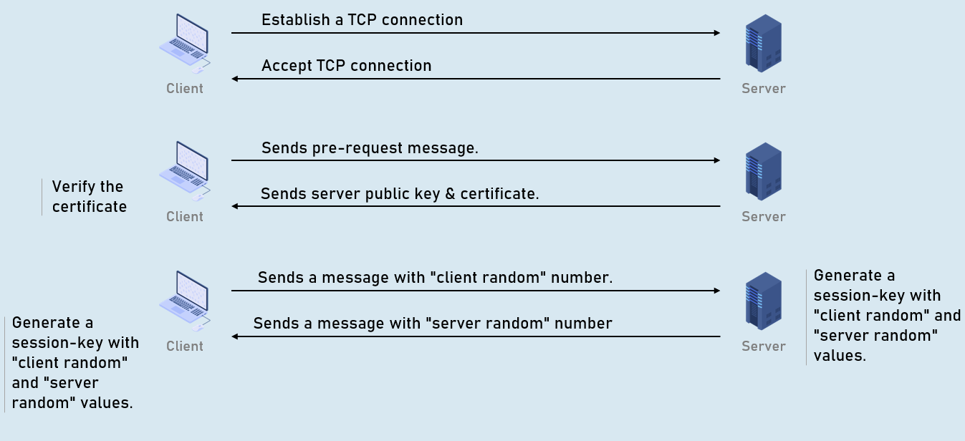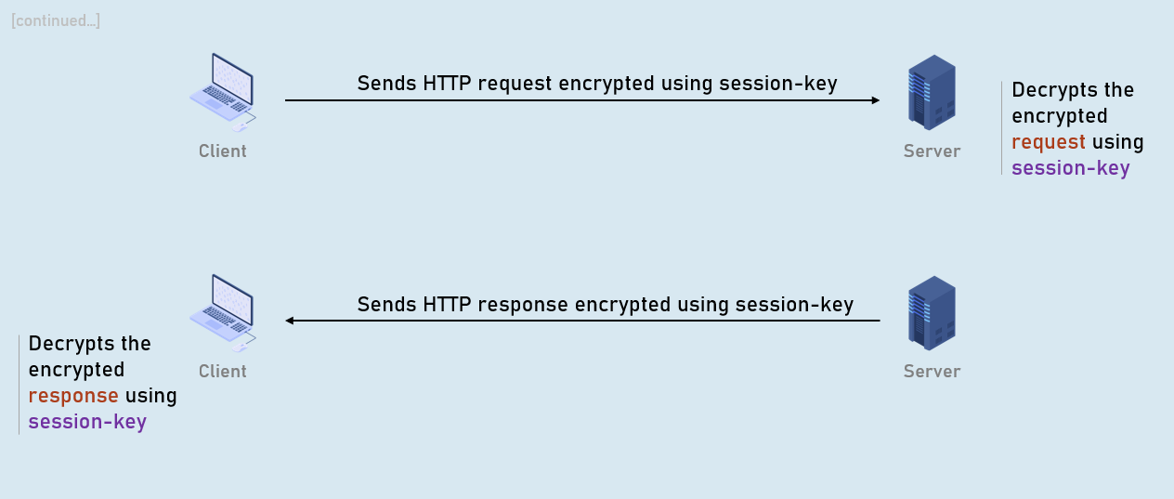

**XSRF**

XSRF (Cross Site Request Forgery - CSRF) is a process of making a request to a web server from another domain, using an existing authentication of the same web server.

Eg: attacker.com creates a form that sends malicious request to original.com.

**Attacker's request without AntiForgeryToken**

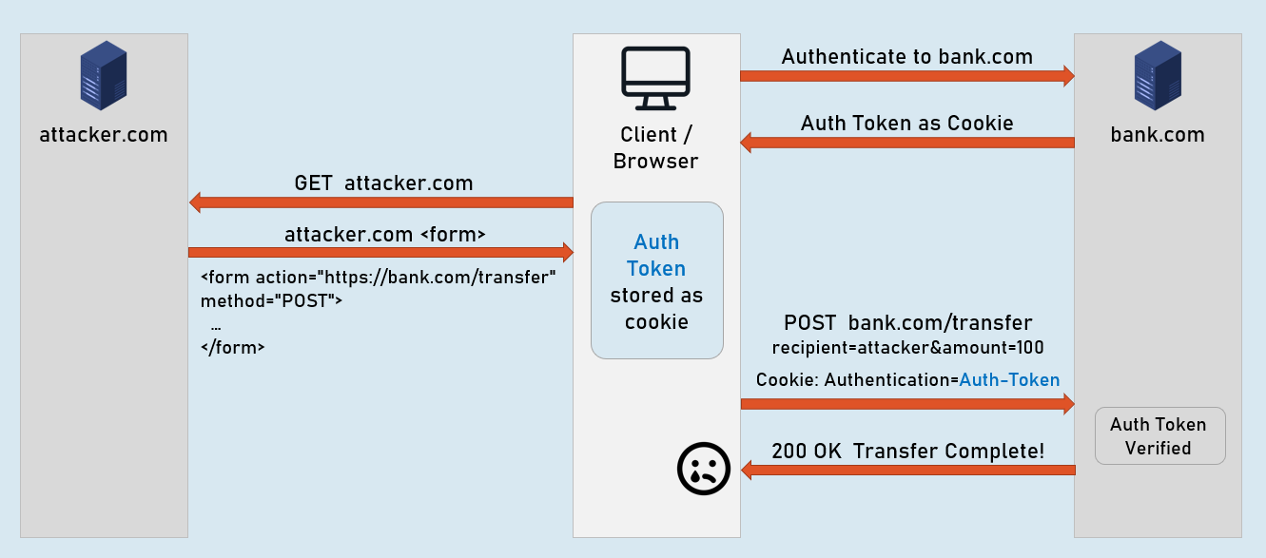

**Attacker's request**

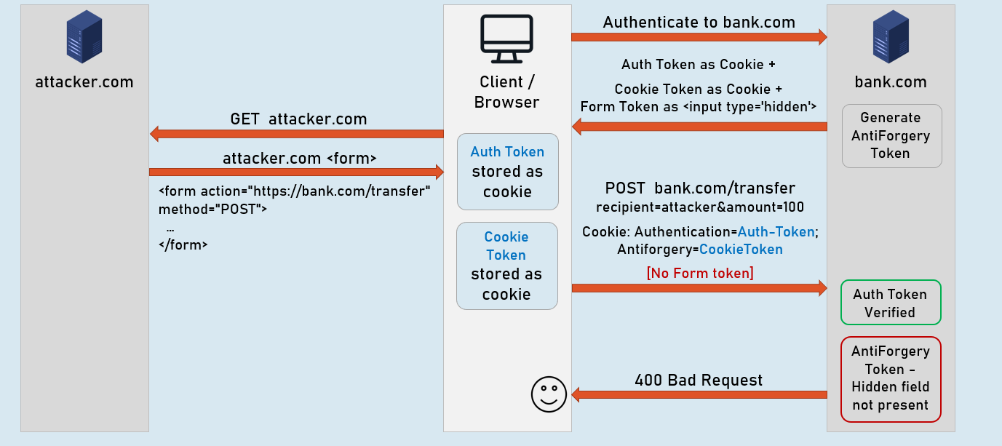

**Legit request [No attacker.com]**

